Approximate Numbers Determiners

🔹 What Are Approximate Number Determiners?
# Source: AI Source: Provided by: [Data Path: Persons Table -> ID Column: 1, Name_En Column: Motasem Essam] -> From: [Chatgpt (GPT-4-turbo)] on [7/28/2025]
Approximate Number Determiners are determiners that express an estimated or non-exact quantity. They give the idea of number without being precise.

✅ Common Examples:
# Source: AI Source: Provided by: [Data Path: Persons Table -> ID Column: 1, Name_En Column: Motasem Essam] -> From: [Chatgpt (GPT-4-turbo)] on [7/28/2025]
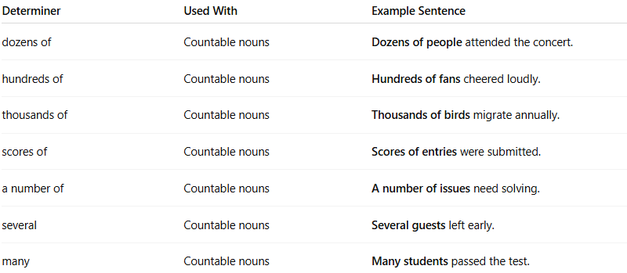
Determiner | Used With | Example Sentence
dozens of | Countable nouns | Dozens of people attended the concert.
hundreds of | Countable nouns | Hundreds of fans cheered loudly.
thousands of | Countable nouns | Thousands of birds migrate annually.
scores of | Countable nouns | Scores of entries were submitted.
a number of | Countable nouns | A number of issues need solving.
several | Countable nouns | Several guests left early.
many | Countable nouns | Many students passed the test.

🔸 Key Features:
# Source: AI Source: Provided by: [Data Path: Persons Table -> ID Column: 1, Name_En Column: Motasem Essam] -> From: [Chatgpt (GPT-4-turbo)] on [7/28/2025]
- Give an approximation, not an exact figure.
- Used before nouns to modify them (thus functioning as determiners).
- Often overlap with quantifiers.

✅ Summary:
# Source: AI Source: Provided by: [Data Path: Persons Table -> ID Column: 1, Name_En Column: Motasem Essam] -> From: [Chatgpt (GPT-4-turbo)] on [7/28/2025]
Approximate Number Determiners express non-specific but countable quantities.
They fall under both determiners and numerical quantifiers depending on usage.

